PYTHON CODE FOR TRAFFIC LIGHT:

X=input(“Enter value:”)

traffic_light=int(x)

While True:

If traffic_light>=1 and traffic_light<10:

Print(‘green light’)

traffic_light+=1

elif traffic_light<20:

Print(‘yellow light’)

traffic_light+=1

elif traffic_light<30:

Print(‘red light’)

traffic_light+=1

else:

traffic_light=0

break

ASSESSMENT NO:03

OUTPUT:

Enter value:27

Red light

>>>>

Enter value:3

Green light

>>>>

Enter value:12

Yellow light

>>>>

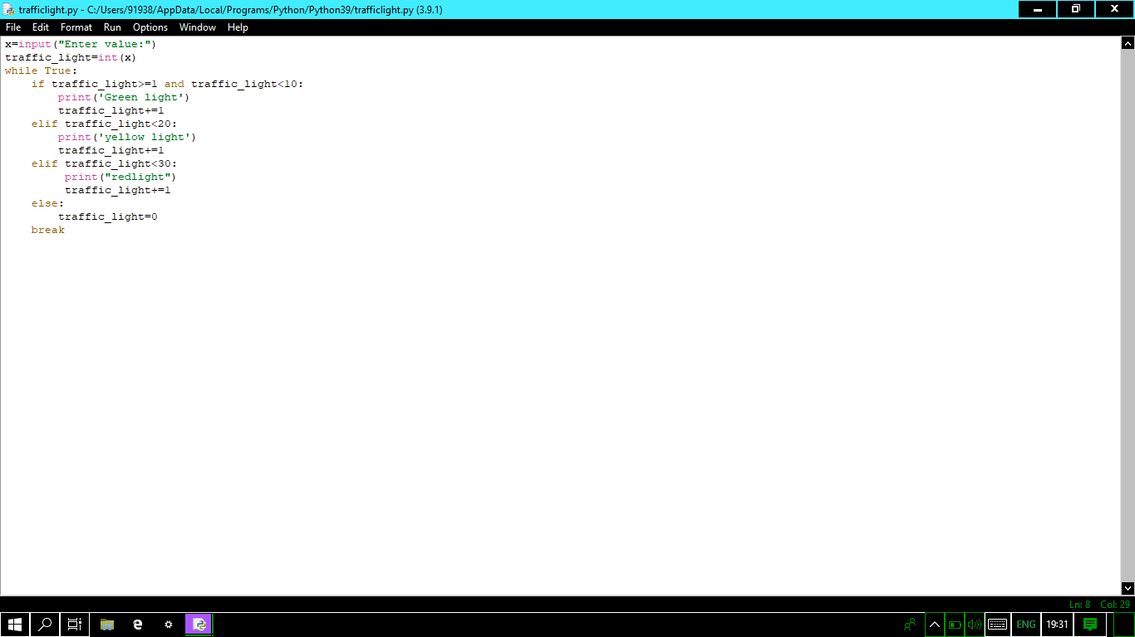

ASSESSMENT NO:03

VARSHA.E

PROGRAM EXECUTION: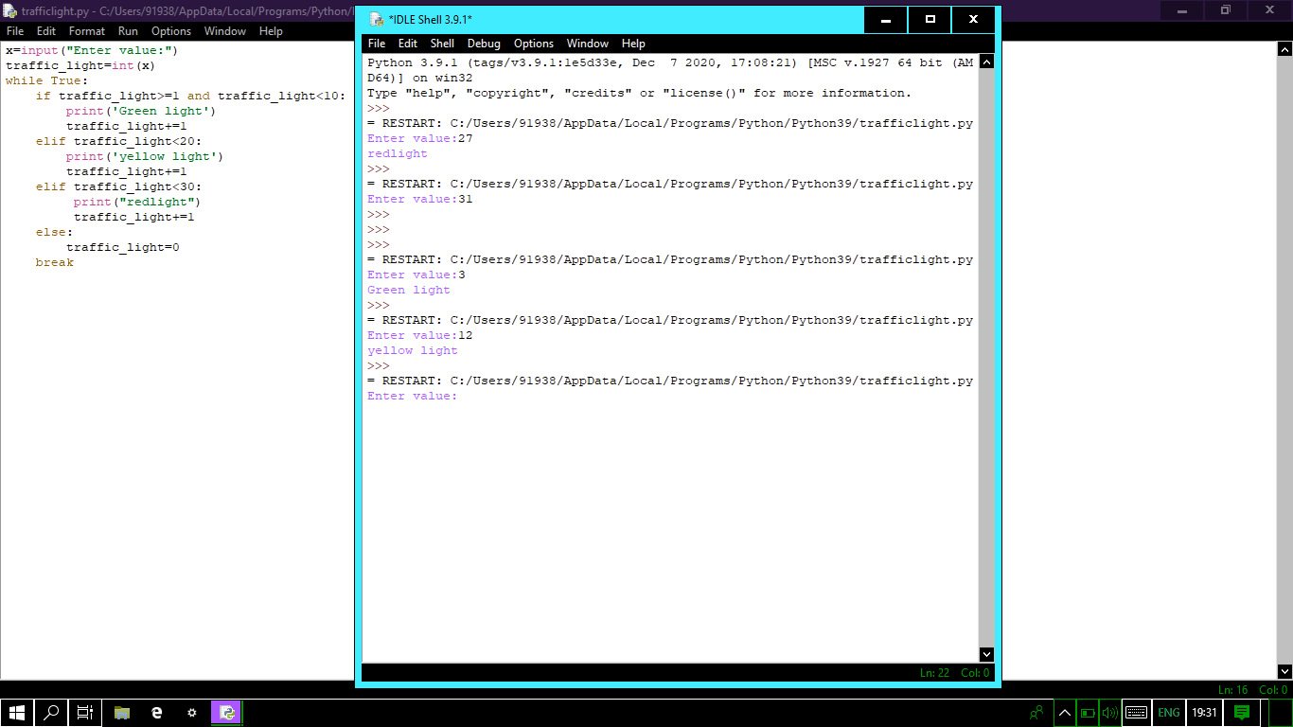

PYTHON CODE FOR BLINKING LED:

X=input(“ENTER VALUE”)

BLINK_LED=int(x)

While True:

If BLINK_LED>=100:

Print(“LED IS BLINKING”)

else:

Print(“NIL”)

OUTPUT:

LED IS BLINKING

LED IS BLINKING

LED IS BLINKING

LED IS BLINKING

LED IS BLINKING

LED IS BLINKING

LED IS BLINKING

PROGRAM EXECUTION: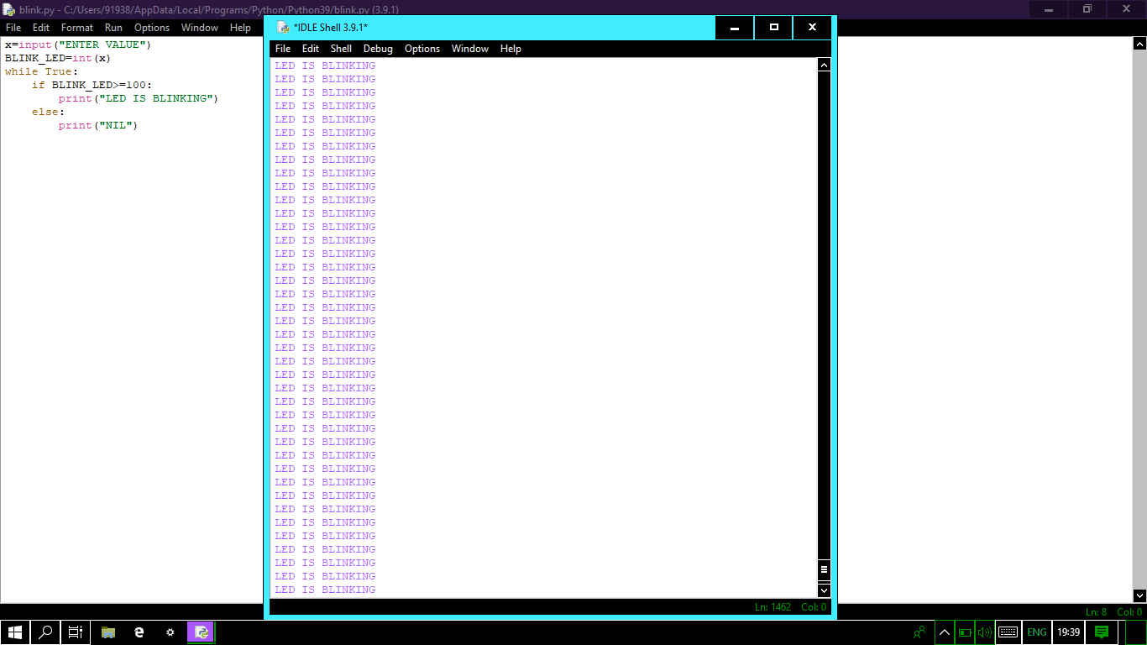

CODE FOR RASEPERRY PI(TRAFFIC LIGHT):

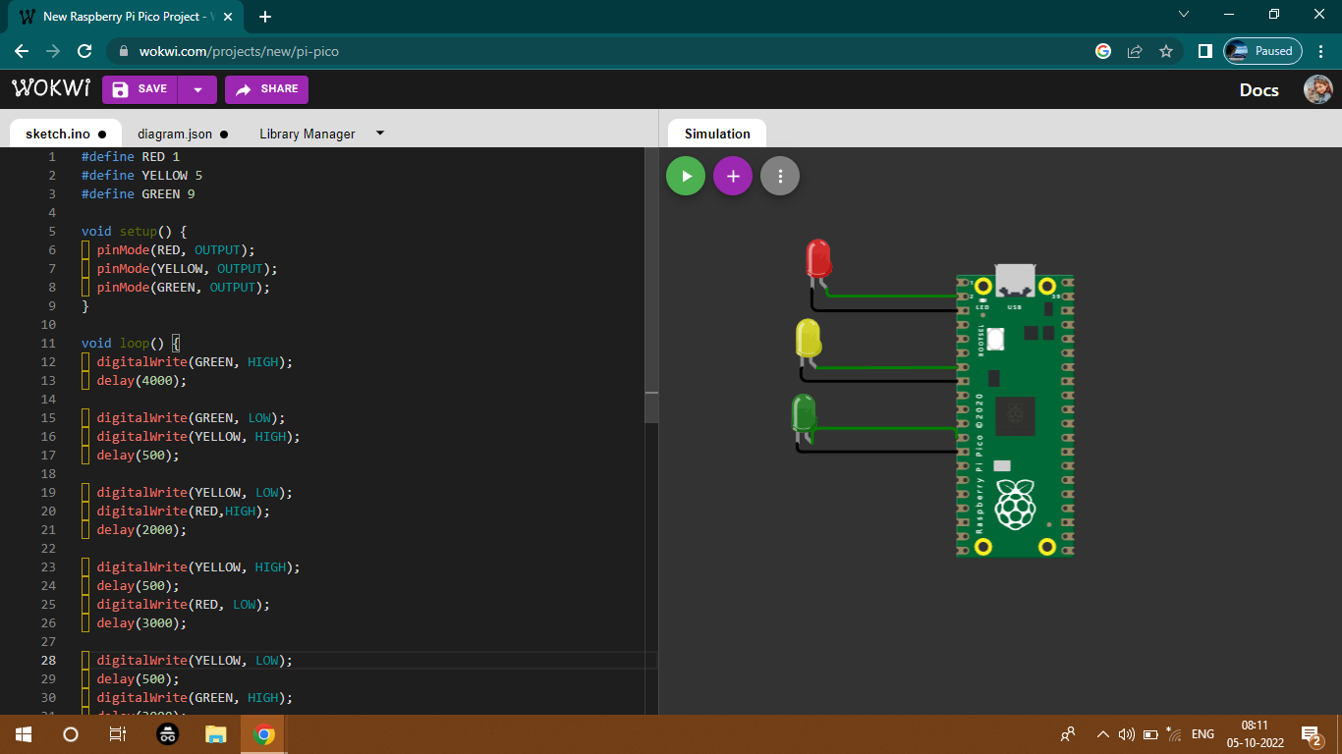

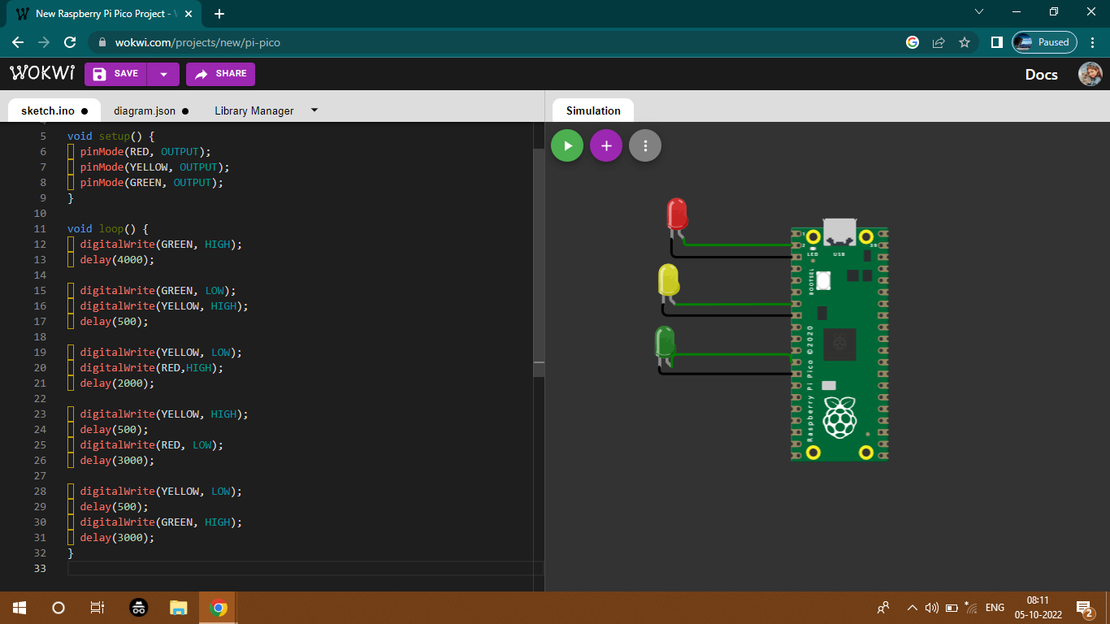

CODE FOR BLINKING LED:

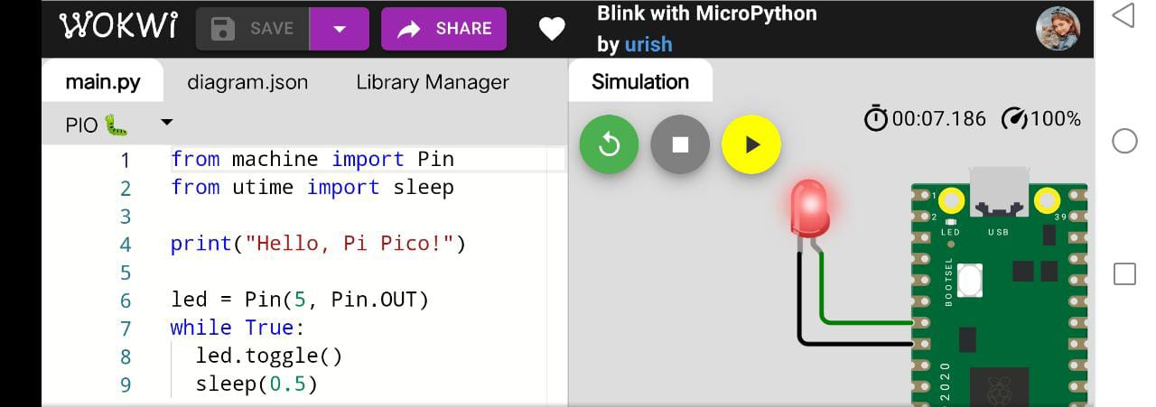

ASSESSMENT NO:03

VARSHA.E